MAMMUT ENTERS THE SOUTH KOREAN MARKET
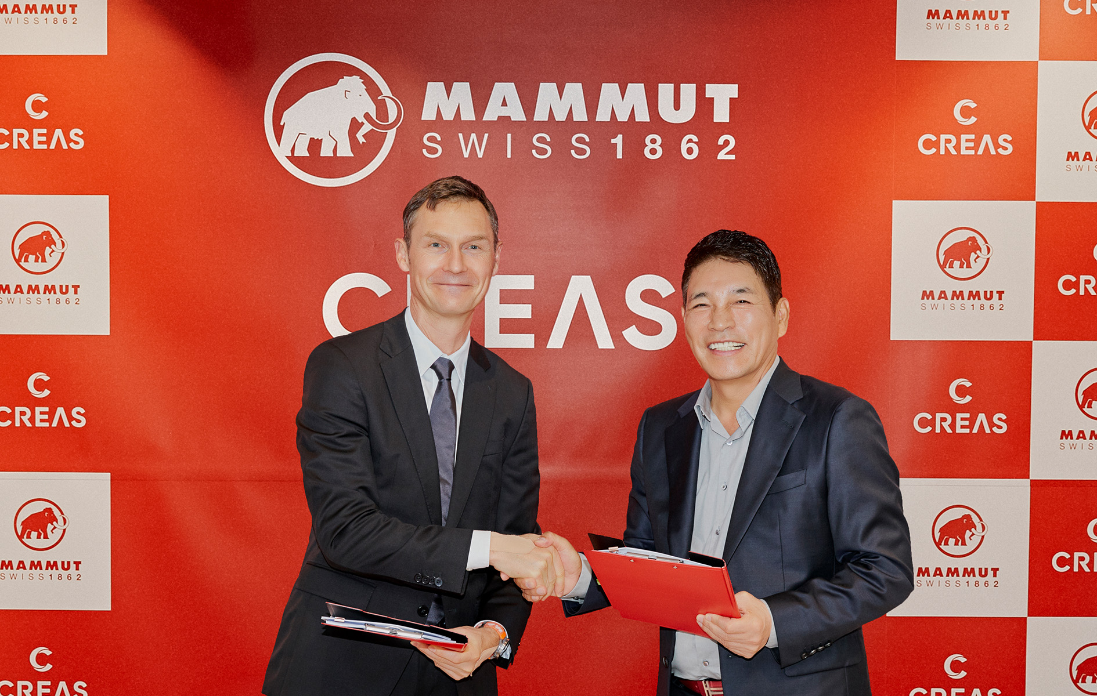
Heiko Schäfer, CEO Mammut, and Jin-Seok Woo, Chairman Creas F&C, are looking forward to working together in Korea. (Image: Creas F&C)

Mammut is excited to re-enter the Korean outdoor market. Following great success in Japan and China, the Swiss premium provider of mountaineering clothing and equipment continues its expansion in Asia and launches with the Autumn/Winter season 2024 in Korea.
Mammut will be represented in Korea by the local distributor Creas F&C Co. Ltd. “We are very pleased to enter the South Korean market together with our strong partner Creas F&C,” says Heiko Schäfer, CEO of Mammut. “Creas F&C has an impressive track record in building premium brands in Korea and will undoubtedly be able to fully exploit our potential in this important outdoor market.”
The business development is supported by the Mammut Japan team, which underlines the effective regional cooperation within the company. “Our experiences in Japan and China were very valuable in defining our market development strategy for Korea,” adds Mammut’s Chief Commercial Officer Felix Münnich.
The South Korean outdoor market is among the three largest in Asia and is characterized by a high appreciation for technical performance and quality of products. “We believe that our high-quality products will match the needs and expectations of South Korean outdoor enthusiasts well,” says Heiko Schäfer.

About Mammut
Founded in 1862, Mammut is a Swiss outdoor company that provides high-quality products and unique brand experiences for fans of mountain sports around the world. This leading international premium brand has stood for safety and pioneering innovation for 160 years. Mammut products combine functionality and performance with contemporary design. With its combination of hardware, shoes and clothing, Mammut is one of the most complete suppliers in the outdoor market. Mammut Sports Group AG operates in around 40 countries and employs around 800 people.
mammut.com

